Registration form
International Conference On
Pesticides and related emerging organic pollutants impact on
the Environment and Human Health and Its Remediation Strategies
7th – 9th November 2024
Organising by EPCET, Bangalore, India

1..Name:___________________________________ Gender: M / F

2. Participant type: Faculty: Research Scholar  Student:  Industry/Research Organisation:  Participation from Abroad: 

3. Designation:___________________ Department___________________

4.College/Industry ______________________________________

5. Address:_________________________________________________________________________________________

_________________________________________ City:_____________________ Pin: _______________________

Phone (M): ____________________

6. Presenting Author Name and Email ID :____________________________________________________________

7. No. of Co-authors are accompanying with presenting Author : _______________

8. Amount of registration fee Paid includes co-authors attending: Rs.________________

Details of Electronic Transfer ID, Bank name /Branch and Date : / DD :- __________________________

Note: Payment Option Details

- For Electronic Transfer: Bank: Federal Bank & Branch: Hirandahalli branch , Bangalore-560049; Account Number: 21630100097715; IFSC Code: FDRL0002163; Account holder's name: Principal- East Point College of Engineering and Technology (EPCET) and Nature of the account: Saving Bank
- Scan QR Code to pay : eastpointsav123@fbl
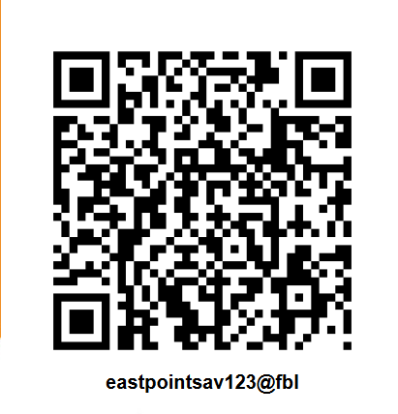

9. Kindly tick as applicable the mode of Registration: Delegate: Oral Presentation: Poster presentation :
(Note: But will consider your abstract for oral or poster presentation based on the conference committee recommendations)

10. Title of Paper/Poster includes all authors’ names:
_____________________________________________________________________________________

____________________________________________________________________________________________

Signature of Head of the Institution (with seal) Signature of Applicant

Note: Photocopies of Registration Forms Accepted
Address for Correspondence: Prof Dr Sreenivasa Rao Amaraneni, Convener, ICPREOPIEHHRS-2024, Department of Chemistry, East Point College ofEngineering & Technology, Jnana Prabha, East Point Campus, Virgo Nagar Post, Avalahalli, Bangalore-560049,Karnataka, India
Phone (M) +91-9972735264; Email:drsreenivasa.chem@eastpoint.ac.in/ pesticideconference2024@gmail.com

